Saint Joseph 2nd Class .
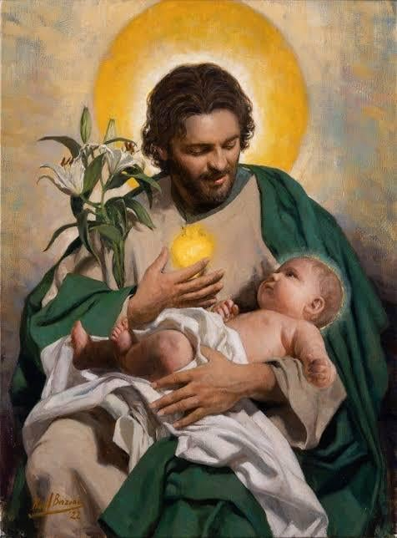
Born:
Died: Before 30 AD
Canonized: Pre- Congregation
Feast: March 19th, May 1st, Sunday after the Nativity, Monday after feast of the Holy Cross
Patronage: The Catholic Church, among others: fathers, virgins, workers, carpenters, married people, persons living in exile, the sick and dying, for a happy death
History of Relic:
Recipient | Date received | Date Returned | Intention
Joseph Samo

